DANIEL M. PHILLIPS LEADERSHIP AWARD WINNERS
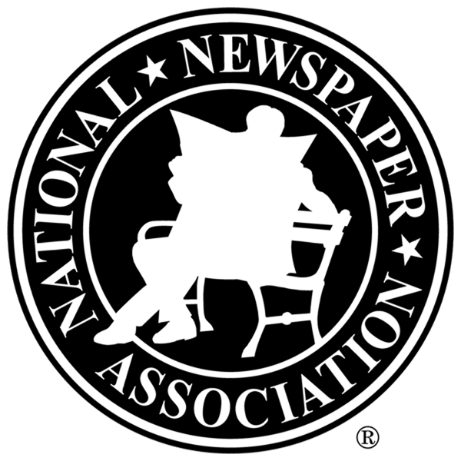
IN STATE ORDER

Iowa
Derek Sawvell, Wilton, IA, 2014

Georgia
Eric NeSmith, Athens, 2013

Mississippi
Joel McNeece, Bruce, 2009

Missouri
Trevor Vernon, Eldon 2017

Nebraska
Jim Edgecombe, Minden, 2008
Gerri Peterson, Mullen, 2011
Chris Rhoades, Blair, 2016

Oklahoma
Jeffrey W. Mayo, Sallisaw, 2010

South Dakota
Jeremy Waltner, Freeman, 2015

No nominations received this year, 2012

